- ‘n Nuwe besending tafelgerei het gearriveer en ons het weer baie slaaistelle, slaaibakke, ens. In voorraad! Gaan loer gerus in ons Online Shop vir die nuutste pryse --------- New shipment of cutlery blanks received – we now have lots of Salad sets, Salad bowls, Ice buckets and Platters in stock. Please see Online shop for latest cutlery prices.

- Laat weet ons asseblief indien u ‘n klas van Astrid Riedel wil bywoon. Haar werk is te sien in ons Gallery en ook by Guest Teachers. Ons sal graag ‘n klas vir haar in Augustus wil aanbied indien daar genoeg belangstelling is -------- Please let us know if you are interested in doing a class with Astrid Riedel. You can see her work in our Gallery as well as under Guest Teachers. We would like to present another class in August if we get enough interested people.

- Ons het ook ‘n paar nuwe kleure glas ontvang -------- We received a few new glass colours:

591411 Ochre
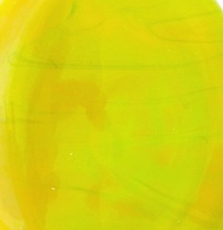

591265 Uraneum yellow pastel:
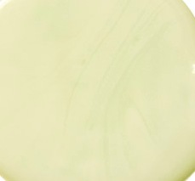

591213 Grasshopper green:
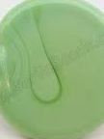

592248 Blue with white core:


